**Aggregate Function**

**Creating Sales Collection:**

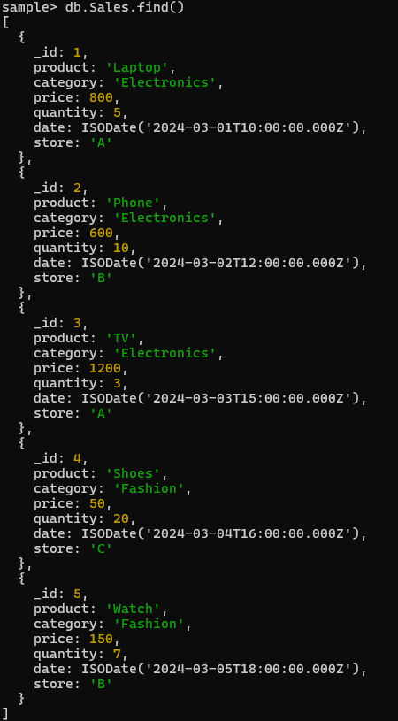

**Query with Output**

1. **Total sales per product**.

db.Sales.aggregate([{$group:{_id:"$product",Total_Sales:{$sum:{$multiply:["$price","$quantity"]}}}}])

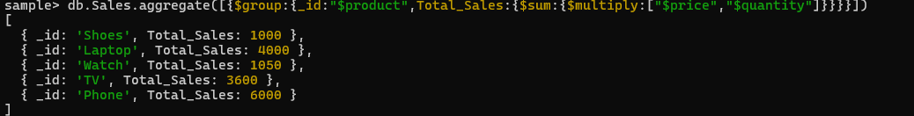

**2. Total revenue per product**.

db.Sales.aggregate([{$group:{_id:"$product",Total_Revenue:{$sum:{$multiply:["$price","$quantity"]}}}}])

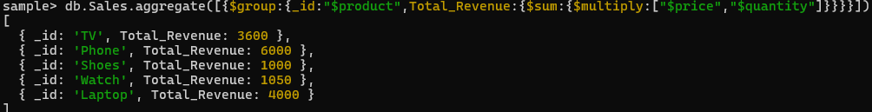

**3. Total revenue per category.**

db.Sales.aggregate([{$group:{_id:"$category",Total_Revenue:{$sum:{$multiply:["$price","$quantity"]}}}}])



**4. Count of products per category.**

db.Sales.aggregate([{$group:{_id:"$category",productCount:{$sum:1}}}])

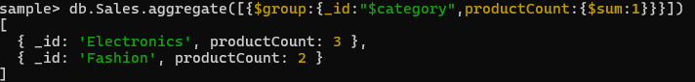

**5. Store-wise total sales.**

db.Sales.aggregate([{$group:{_id:"$store",Total_Sales:{$sum:{$multiply:["$price","$quantity"]}}}}])

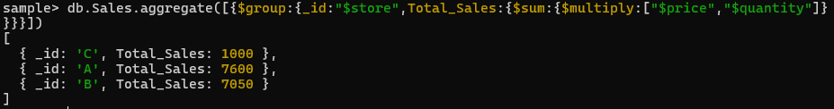

**6. Average price of products per category**.

db.Sales.aggregate([{$group:{_id:"$category",Average_Price:{$avg:"$price"}}}])

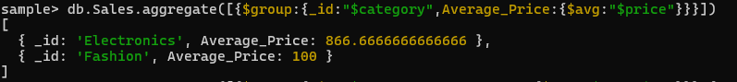

**7. Top-selling product**.

db.Sales.aggregate([{$group:{_id:"$product",Total_Sales:{$sum:"$quantity"}}},{$sort:{Total_Sales:-1}},{$limit:1}])



**8. Total sales for Electronics category.**

db.Sales.aggregate([{$match:{category:"Electronics"}},{$group:{_id:"Electronics",Total_Sales:{$sum:{$multiply:["$price","$quantity"]}}}}])



**9. Sales trend over time (day-wise total sales).**

db.Sales.aggregate([{$group:{_id:{$dateToString:{format:"%Y-%m-%d",date:"$date"}},Total_sales:{$sum:{$multiply:["$price","$quantity"]}}}}])

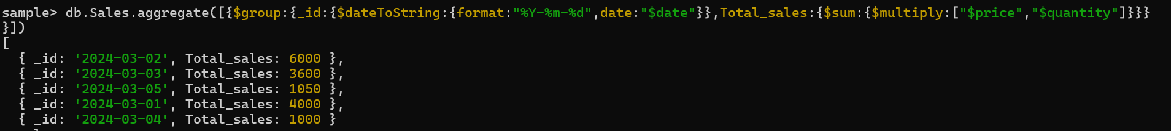

**10. Highest revenue-generating product.**

db.Sales.aggregate([{ $group: { _id: "$product", Total_Revenue: { $sum: { $multiply: ["$price", "$quantity"] } } } }, { $sort: { Total_Revenue: -1 } }, { $limit: 1 }])



**11. Average revenue per sale**.

db.Sales.aggregate([{$project:{sales:{$multiply:["$price","$quantity"]}}},{$group: {_id:"category",Average_revenue_p_sales: { $avg: "$sales" }}}])



**12. Sales performance per store**.

db.Sales.aggregate([ { $group: { _id: "$store", Sales_Per_Store: { $sum: { $multiply: ["$price", "$quantity"] } } } }])



**13. Products sold more than 5 times**.

db.Sales.aggregate([{$group:{_id:”$product”,Total_Sales:{$sum:”$quantity”}}},{$match:{Total_Sales:{$gt:5}}}])



**14. Least sold product.**

db.Sales.aggregate([{$group:{_id:”$product”,Total_Sales:{$sum:”$quantity”}}},{$sort:{Total_Sales:1}},{$limit:1}])



**15. Monthly sales summary**.

db.Sales.aggregate([{$group:{_id:{$dateToString:{format:"%Y-%m",date:"$date"}},Total_sales:{$sum:{$multiply:["$price","$quantity"]}}}}])

**16. Number of unique products sold.**

db.Sales.aggregate([{$group:{_id:"product",uniqueProducts:{$addToSet:"$product"}}},{$project:{uniqueProducts:{$size:"$uniqueProducts"}}}])

**17. Maximum and minimum priced product.**

db.Sales.aggregate([{$group:{_id:"price",Max_Price:{$max:"$price"},MinPrice:{$min:"$price"}}}])

**18. Total revenue per product in descending order**.

db.Sales.aggregate([{$group:{_id:"$product",Total_Revenue:{$sum:{$multiply:["$price","$quantity"]}}}},{$sort:{Total_Revenue:-1}}])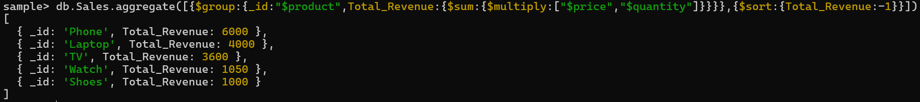

**19. Revenue generated per store per category.**

db.Sales.aggregate([{$group:{_id:{store:"$store",category:"$category"},Total_Revenue:{$sum:{$multiply:["$price","$quantity"]}}}}])

**20. Products contributing more than 50% revenue**.

db.Sales.aggregate([{$group:{_id:"$product",Total_Revenue:{$sum:{$multiply:["$price","$quantity"]}}}},{$match:{Total_Revenue:{$gt:{$multiply:["$Total_Revenue",0.5]}}}}])